UNITED STATES

SECURITIES AND EXCHANGE COMMISSION
Washington, D.C. 20549

FORM 6-K

REPORT OF FOREIGN PRIVATE ISSUER PURSUANT TO RULE 13a-16 OR 15d-16 UNDER THE SECURITIES EXCHANGE ACT OF 1934

For the month of May, 2026.

Commission File Number: 001-40530

GH Research PLC

(Exact name of registrant as specified in its charter)

Joshua Dawson House

Dawson Street

Dublin 2

D02 RY95

Ireland

(Address of principal executive office)

Indicate by check mark whether the registrant files or will file annual reports under cover of Form 20-F or Form 40-F:

Form 20-F ☒ Form 40-F ☐

GH Research PLC (the “Company”) will attend the American Society of Clinical Psychopharmacology (“ASCP”) Annual Meeting, which is scheduled to take place from May 26 – 29, 2026, in Miami, Florida (the “Congress”).

The Company will present posters during the Congress as part of Poster Session I.

A copy of the poster to be presented by Roger S. McIntyre is attached hereto as Exhibit 99.1.

A copy of the poster to be presented by Michael E. Thase is attached hereto as Exhibit 99.2.

A copy of the poster to be presented by Wiesław J. Cubała is attached hereto as Exhibit 99.3.

1

Exhibit Index
Exhibit No. |  | Description
99.1 |  | Poster presented by Roger S. McIntyre, with Title: Rapid and Sustained Improvement in Anhedonia Following Inhaled Mebufotenin (GH001) Treatment in Patients With Treatment-Resistant Depression
99.2 |  | Poster presented by Michael E. Thase, with Title: GH001 Efficacy is Independent of Prior Antidepressant Treatment Failures in Treatment-Resistant Depression: A Post Hoc Analysis of a Phase 2b
 |  | Randomized Controlled Trial
99.3 |  | Poster presented by Wiesław J. Cubała, with Title: Impact of GH001 on Depressive Symptoms, Anxiety, and Quality of Life in Treatment-Resistant Depression: Results from a Phase 2b Trial
 |  | 2

SIGNATURE

Pursuant to the requirements of the Securities Exchange Act of 1934, the registrant has duly caused this report to be signed on its behalf by the undersigned, thereunto duly authorized.

GH Research PLC
Date: May 21, 2026
By: | /s/ Julie Ryan
Name: | Julie Ryan
Title: | Vice President, Finance
3

Exhibit 99.1
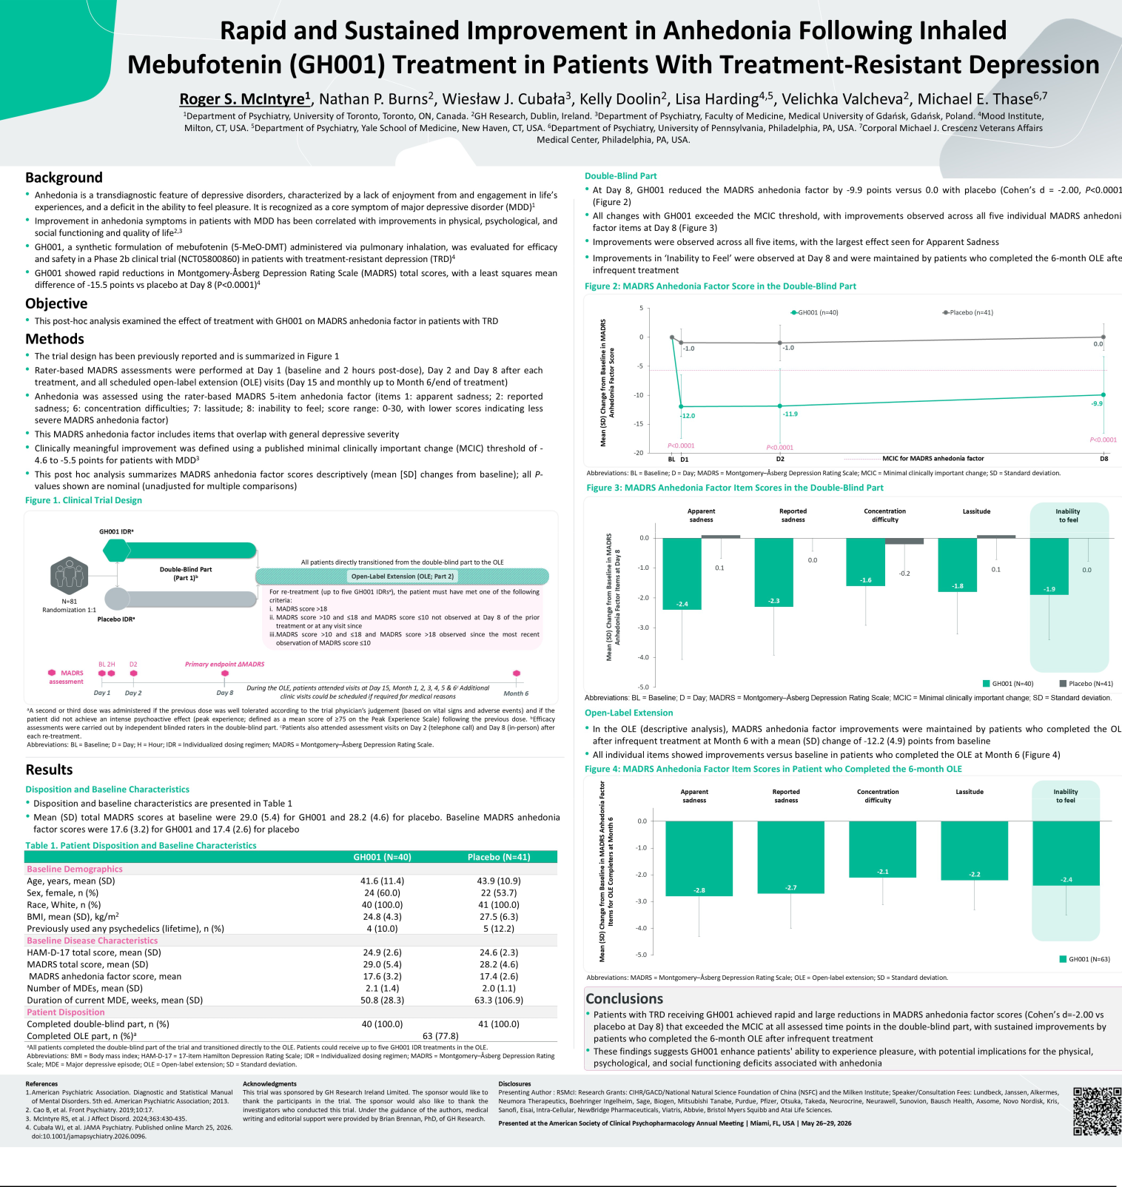

Exhibit 99.2
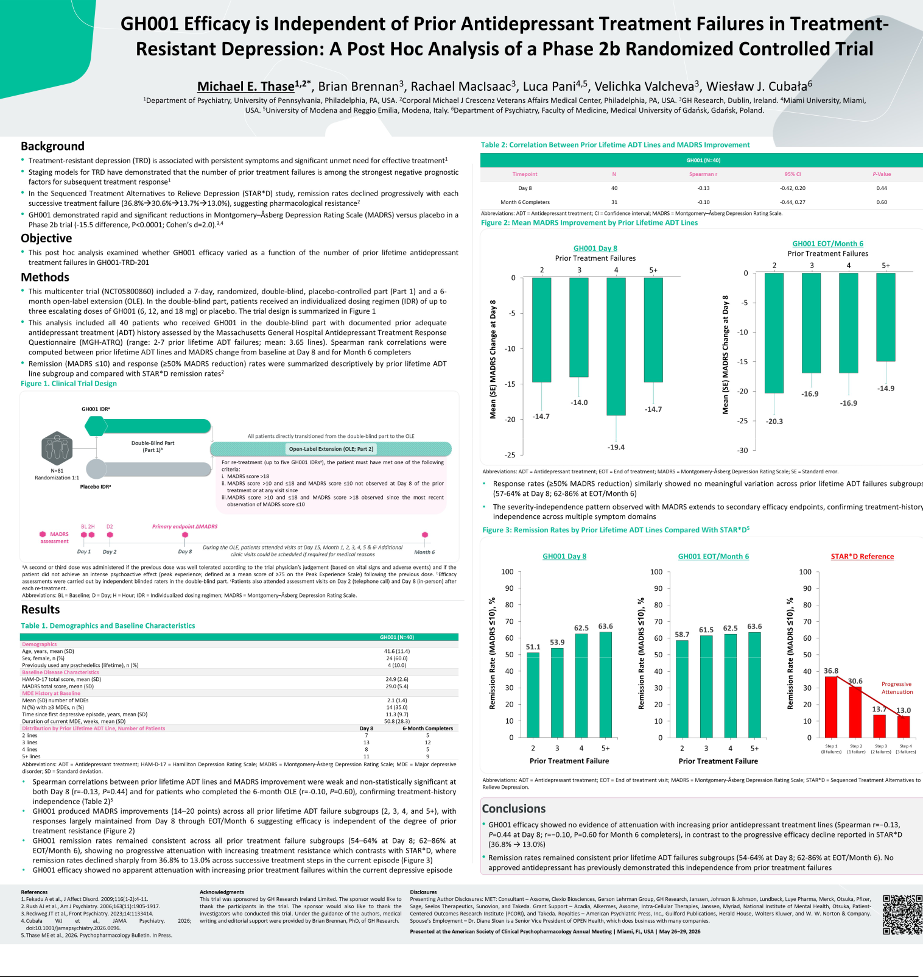

Exhibit 99.3


